LINKS –

1. <https://www.programiz.com/python-programming/regex>
2. <https://docs.python.org/2/library/calendar.html#calendar.setfirstweekday>
3. <https://docs.python.org/2/library/datetime.html#module-datetime>
4. <https://docs.python.org/2/library/time.html#module-time>
5. https://youtu.be/eKp56OLhoQs

One of the good algorithm he forwarded me

To find prime in a range

1. <https://github.com/rjrealworld/python-games>
2. <https://github.com/Priyansi/pythonPrograms>

ASOKAN ARTICLE

1. <https://www.quantamagazine.org/computer-scientist-donald-knuth-cant-stop-telling-stories-20200416/>
2. <https://en.wikipedia.org/wiki/Stephen_C._Johnson>
3. <https://www.quantamagazine.org/john-conway-solved-mathematical-problems-with-his-bare-hands-20200420/>

BOOKS -

1. Programming and Problem solving in python by kamthane
2. Corey Schafer - Python Programming Tutorials

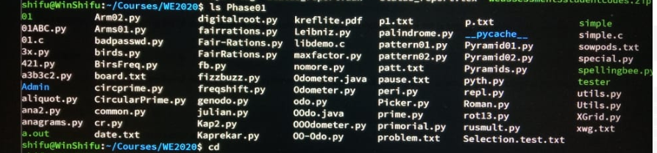

Hey girls, we keep forgetting the points that Asokan has been repeatedly telling us for corrections in our code. I think we could together make a list to refer to everytime we are coding. Please add your own points in continuation.

1. Good variable names(take at least 20mins)

2. Declaring named constants (in CAPITALS)

3. Spaces before and after operators

4. Do not convert an iterable object into list

5. Functions should return "True" or "False". Only main (driver) should return final result.

6. Don't use global variables

7. Don't loop over index

8. Don't write if () return True else return False

9. Data is code, Code is Data

10. Know your interpreter in and out

11. READ THE PYTHON DOCUMENTATION AMMA

12. Writing in caps seems like you are shouting lady

13. Don't use capital letters for variable names like...."Amma"

14. Prefer verbs for function names

15. Ideally, for small problem, spend 15-20 min thinking about it, 5 min to code, and next 5 min to debug and run.

16. Don't just rely on test cases, before testing, think of all possible edge cases.

17. Try using preprocessing data wherever possible.

18. Avoid the use of indices, being said that,

For i in range (len()) is not acceptable.

19. More functions != better code.

20. Always try to go back and backtrack your thinking process.

21. Don't use magic numbers all over the country side (i.e. numbers other than 0 or 1)

22. Don't do set(list), rather declare it as a set from the beginning.

23.When in doubt DON'T use a list

24. never make a list of characters, always use a string instead

25. Don’t say I can like you are doing a favour to me say I will

Don’t use words like "like", "you know", "basically", "I think", "split into lists" etc

26.Don't keep saying SORRY when you make a mistake

26.Don't make variables names on data structures or computer science words

27. for i in range(len(list)) can be written as,

for i, n in enumerate(list)

Here i is index and n is the value at that index

[5:23 PM, 6/21/2020] Nimisha: What does random.seed () do in python?

[5:23 PM, 6/21/2020] Nimisha: Well, it gets you the same set of random numbers every time you run the program so that your training and validation datasets can remain completely seperate. If the validation data seeps in the training data, then it'll affect the validation score.

[5:23 PM, 6/21/2020] Nimisha: As in normal programs each time we call random.randint() the value returned by it changes right?

[5:23 PM, 6/21/2020] Nimisha: Yep

[5:23 PM, 6/21/2020] Nimisha: And that's why random.seed

TALENT SPRINT CODES –

PROGRAM 41 –

PERFECT SQUARES

Write a function that returns all the perfect squares below thousand that are expressible as the sum of a cube and a square.

For example, 10 ** 3 + 15 ** 2 = 1225 = 35 ** 2. Note that the example given is more than 1000.

Your function should return a list of integers.

**Additional conditions:** None

**Input:**none

**Output:** List

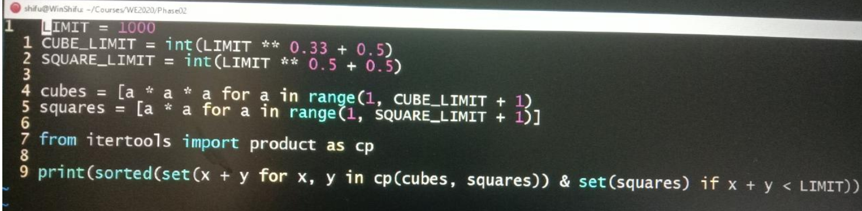

CODE –

def qsqsq() -> [int]:

display=[]

for i in range(0, 100):

for j in range(1,i):

for k in range(1,i):

if(i**2 == j**3 + k**2 and i**2<1000):

display.append(i**2)

display=list(set(display))

display.sort()

return display

PROGRAM 42 –

PYTHAGORIAN TRIAD

A Pythagorean triad is three integers that can be the lengths of the sides of a right angled triangle. (3, 4, 5) is of course the most well known. The perimeter of that triangle is 12.

There are no other right angled triangle with 12 as the perimeter. But there are three right angled triangles, (20, 48, 52), (24, 45, 51) and (30, 40, 50) which have the perimeter of 120.

**Note**that we do not count (48, 20, 52) or (52, 20, 48) as different triangles. You can assume that the standard form of a triad is one where the three sides are in ascending order.

For one value of the perimeter below 1000 the number of triplets with that perimeter is maximum. Write a function to find that value.

**Signature:** peri() -> int

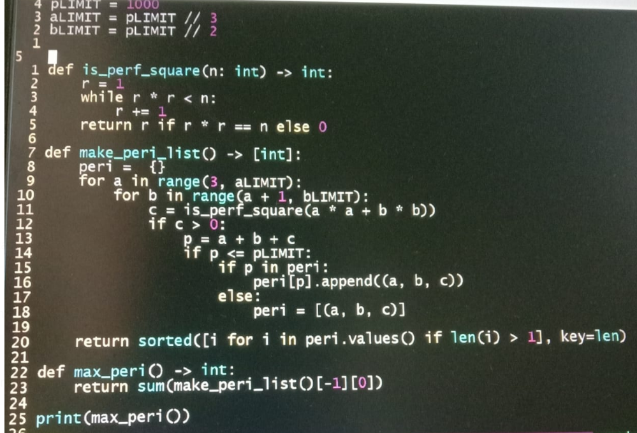

CODE –

from functools import *

from collections import *

def peri() -> int:

final =[]

for i in range(0, 450):

for j in range (i+1, 450):

for k in range (j+1, 450):

if i**2 + j**2 == k**2 :

final.append([i,j,k])

sumList=[]

for i in final:

sumList.append(sum(i))

sumlist=Counter(sumList)

return (sumlist.most_common(1)[0][0])

PROGRAM 43 –

JUMBLED STRING

Write a function that produces a new string by selecting letters in a given string as per the following rule:

The function takes a string and a starting integer START   arguments.

In the first step it visits the character at index START. Then it visits the next character: that is at START + 1. In the next step it visits two characters after that; that is START + 3, then three characters after that: that is START + 6 and so on. If the string ends it goes around to the beginning. It stops when 10 characters have been visited.

**Signature:** pick10(s: str, n:int) -> str

**Additional condition:** return string length is 10 characters

**Input:** String, Int

**Output:** String

**Sample Input:** "ABC", 1

**Sample Output:** "BCBBCBBCBB"

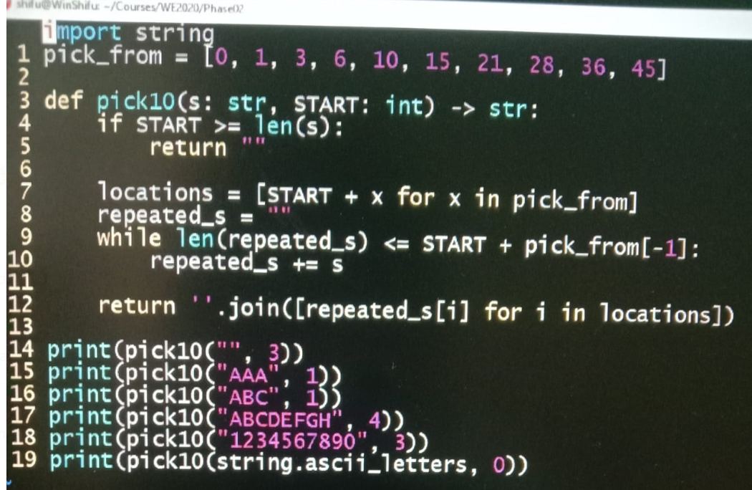

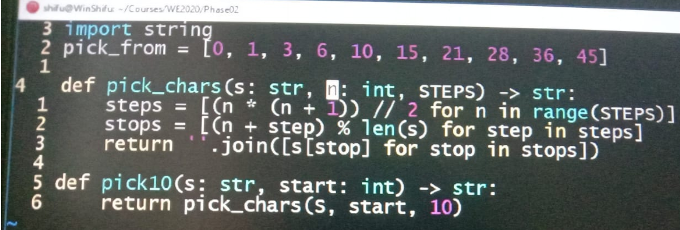

CODE –

from math import *

def pick10(s: str, n:int) -> str:

final=[]

p=ceil(n+55//len(s))

s=s*p

index=n

for i in range(0,10):

index += i

final.append(s[index])

final="".join(final)

return final

PROGRAM 44 –

PRIMITIVE PYTHAGOREAN TRIADS

I hope you noticed that in Pythagorean Triads question, (30, 40, 50) triad can be produced by multiplying all sides of (3, 4, 5) with 10. Similarly (20, 48, 52) can be reduced to (5, 12, 13). Triads which cannot be reduced or derived from others are called primitive pythogoren triads. (3, 4, 5), (5, 12, 13), (7, 24, 25) are primitive triads, for example.

Write a function that generates all primitive pythogorean triads where the sides are all less than 100.

**Signature:**primitive_pyth() -> [(int, int, int)]

**Additional condition**: All three ints less than 100

**Input:** none

**Output:** List of tuples

CODE –

def gcd(a, b):

if a==0:

return b

return gcd(b%a, a)

def primitive_pyth() -> [(int, int, int)]:

final=[]

for i in range(0, 100):

for j in range(i+1, 100):

for k in range(j+1, 100):

if i**2 + j**2 == k**2:

x=gcd(i,j)

if x==1:

final.append((i, j, k))

return final

PROGRAM 45 –

PRINT NUMBERS INTO INDIAN AND AMERICAN NUMBERING SYSTEM

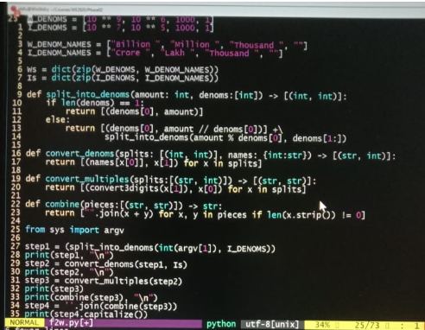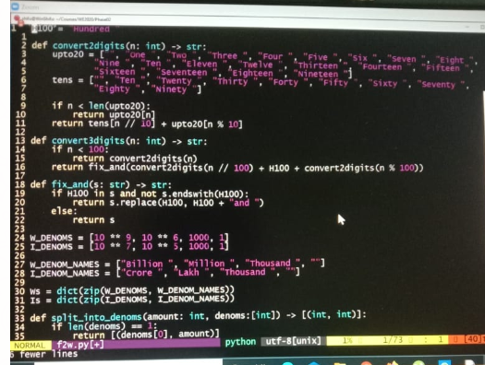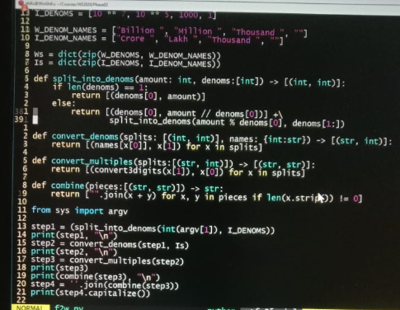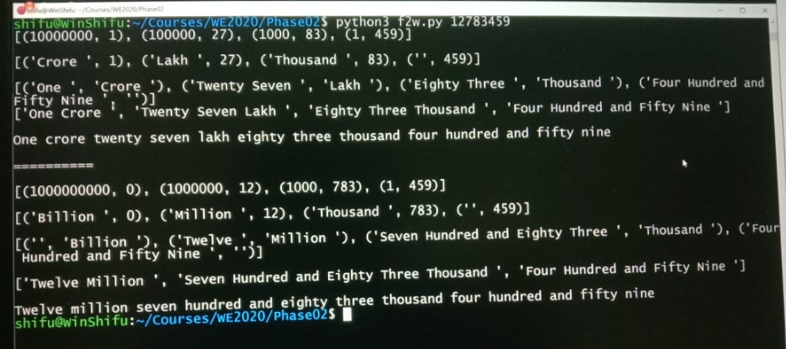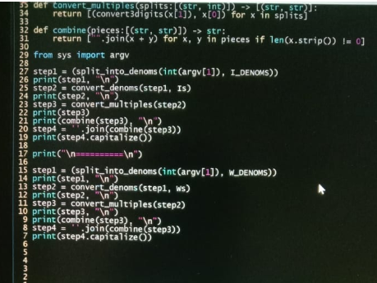

PROGRAM 46 –

EXPAND NUMBER

Create a function that takes a number and return a string with the number in expanded notation.

**Examples**

expand(13) - "10 + 3"

expand(86) - "80 + 6"

expand(17000000) - "10000000 + 7000000"

expand(5325) - "5000 + 300 + 20 + 5"

CODE -

def expand(num):

count = 1

final = ''

while (num != 0):

rem = num % 10

num = num // 10

if (rem != 0):

final = str(rem * count) + ' + ' + final

count = count * 10

return final.rstrip(' + ')

PROGRAM 47 –

BALANCED PARANTHESIS

Write a function that groups a string into parentheses cluster. Each cluster should be balanced.

**Examples**

SplitParenthesis("()()()") - ["()", "()", "()"]

SplitParenthesis("((()))") - ["((()))"]

SplitParenthesis("((()))(())()()(()())") - ["((()))", "(())", "()", "()", "(()())"]

SplitParenthesis("((())())(()(()()))") - ["((())())", "(()(()()))"]

CODE –

def SplitParenthesis(txt):

final = []

b = 0

for i in range (0, len(txt)):

if b == 0:

o = i

if txt[i] == "(":

b += 1

if txt[i] == ")":

b -= 1

if b == 0:

final.append(txt[o : i + 1])

return (final)

PROGRAM 48 –

KEMPNER NUMBER

The Kempner Function, applied to a composite number, permits to find the smallest integer greater than zero which factorial is exactly divided by the number.

kempner(6) - 3

1! = 1 % 6 > 0

2! = 2 % 6 > 0

3! = 6 % 6 === 0

kempner(10) - 5

1! = 1 % 10 > 0

2! = 2 % 10 > 0

3! = 6 % 10 > 0

4! = 24 % 10 > 0

5! = 120 % 10 === 0

A Kempner Function applied to a prime will always return the prime itself. Given an integer n, implement a Kempner Function.

CODE –

def isPrime (n) :

if n in [2, 3, 5, 7 ]:

return True

if n % 2 == 0 or n % 3 == 0 :

return False

r = 5

while r * r <= n:

if n % r == 0:

return False

r += 2

if n % r == 0:

return False

return True

def kempner(n):

if (isPrime(n) == True):

return n

else:

fact = 1

for i in range (1,n+1):

for j in range (1,i+1):

fact = fact * j

if (fact % n == 0):

return i

fact = 1

PROGRAM 49 -

MORAN / HARSHAD NUMBER

A Harshad number is a number which is divisible by the sum of its digits. For example, 132 is divisible by 6 (1+3+2).

A subset of the Harshad numbers are the Moran numbers. Moran numbers yield a prime when divided by the sum of their digits. For example, 133 divided by 7 (1+3+3) yields 19, a prime.

Create a function that takes a number and returns "M" if the number is a Moran number, "H" if it is a (non-Moran) Harshad number, or "Neither".

Examples

moranNumbers(132) - "H"

moranNumbers(133) - "M"

moranNumbers(134) - "Neither"

CODE –

def isPrime (n):

if n in [2, 3, 5, 7]:

return True

if n % 2 == 0 or n % 3 == 0:

return False

r = 5

while r * r <= n:

if n % r == 0:

return False

r += 2

if n % r == 0:

return False

return True

def moranNumbers(n):

sum=0

temp = n

while temp > 0:

sum = sum + temp % 10

temp = temp // 10

p1 = n / sum

p2 = n // sum

if (p1 == p2):

prime = isPrime(p2)

if prime == True:

return "M"

if n % sum == 0 :

return "H"

else:

return "Neither"

PROGRAM 50 –

LOOK AND SAY

Given a number with an even number of digits, return a new number according to the rules below:

* Split the number into groups of two digit numbers. If the number has an odd number of digits, return 'invalid'.

* For each group of two digit numbers, concatenate the last digit to a string to the same number of times as the value of the first digit.

Return the result as an integer.

**Example**

look_and_say(3132) - 111222

# By reading the number digit by digit, you get three '1' and three '2'.

# Therefore, you put three ones and three twos together.

# Remember to return an integer.

CODE –

def look_and_say(n):

sn = str (n)

if len(sn) % 2 == 1:

return "invalid"

expand = []

for i in range(1, len(sn), 2):

expand.append(sn[i] * int(sn[i-1]))

return int("".join(expand))

PROGRAM 51 –

GAME OF LIFE

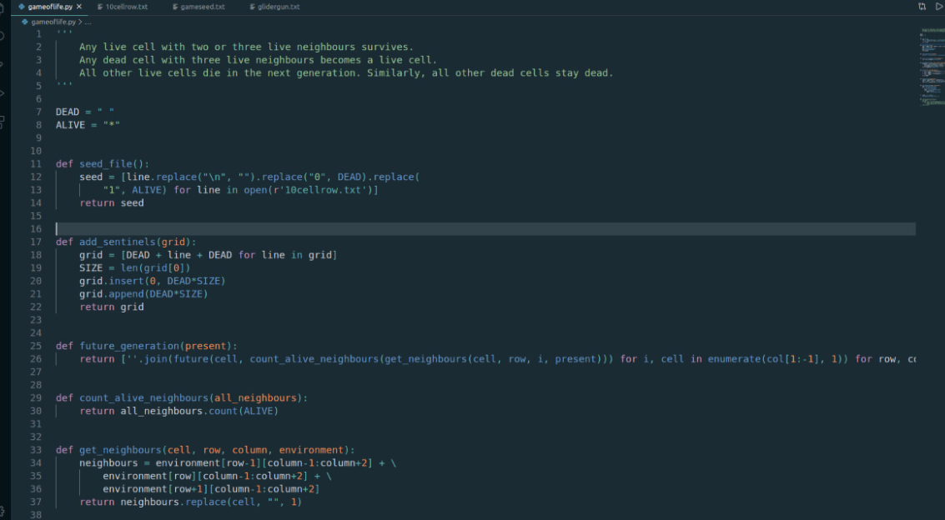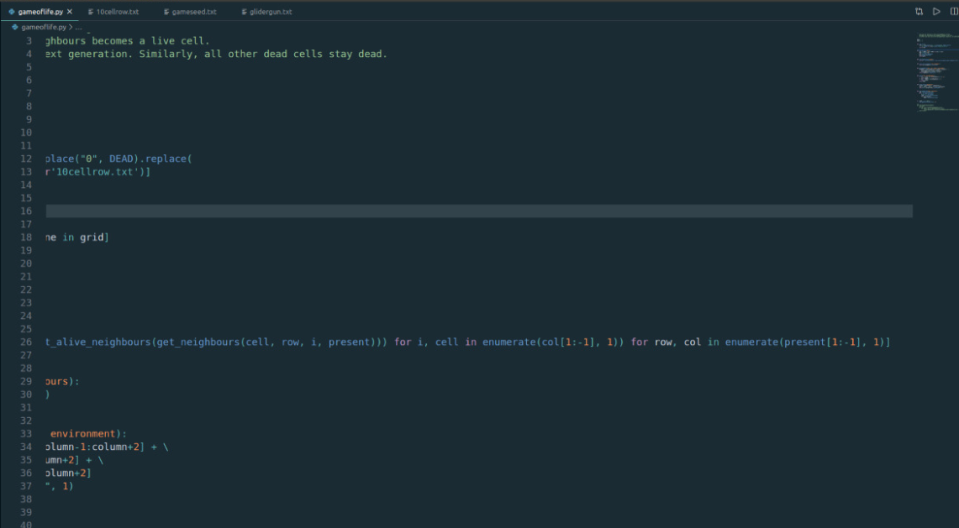

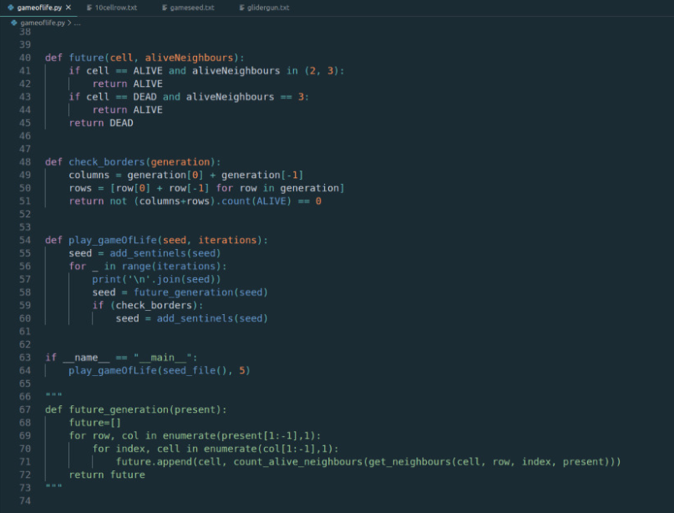

BY HARNAMAN

https://github.com/khssupriya/GameOfLife

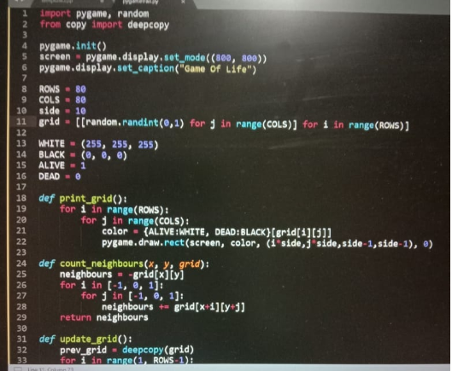

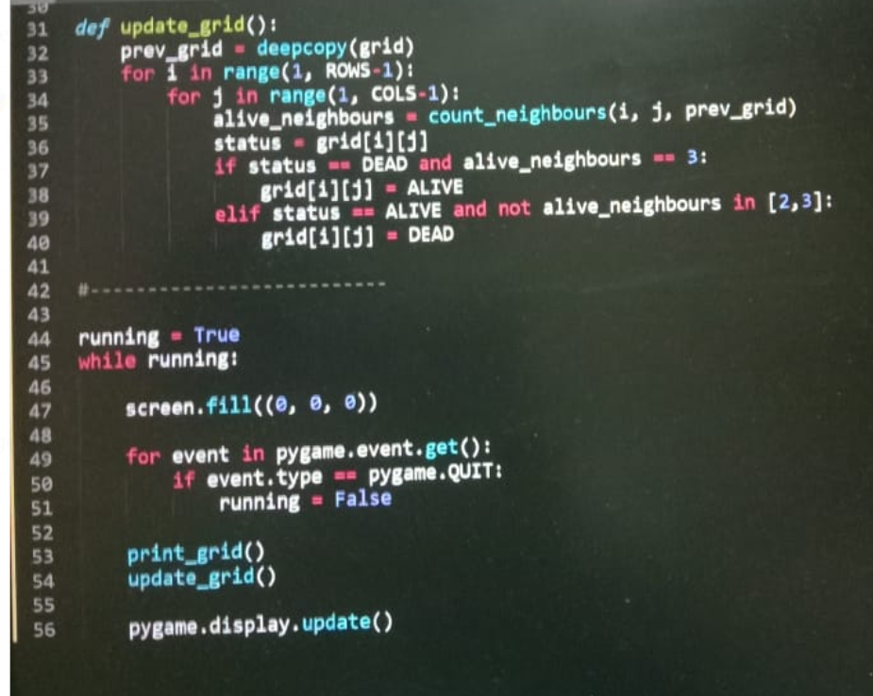

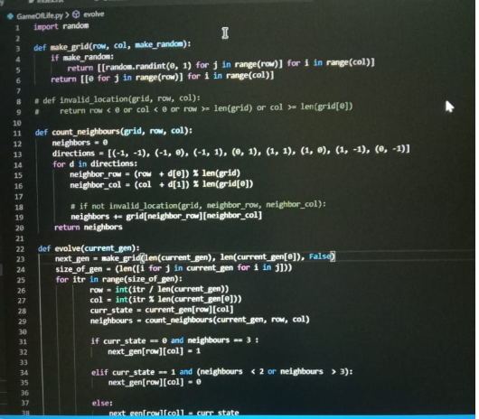

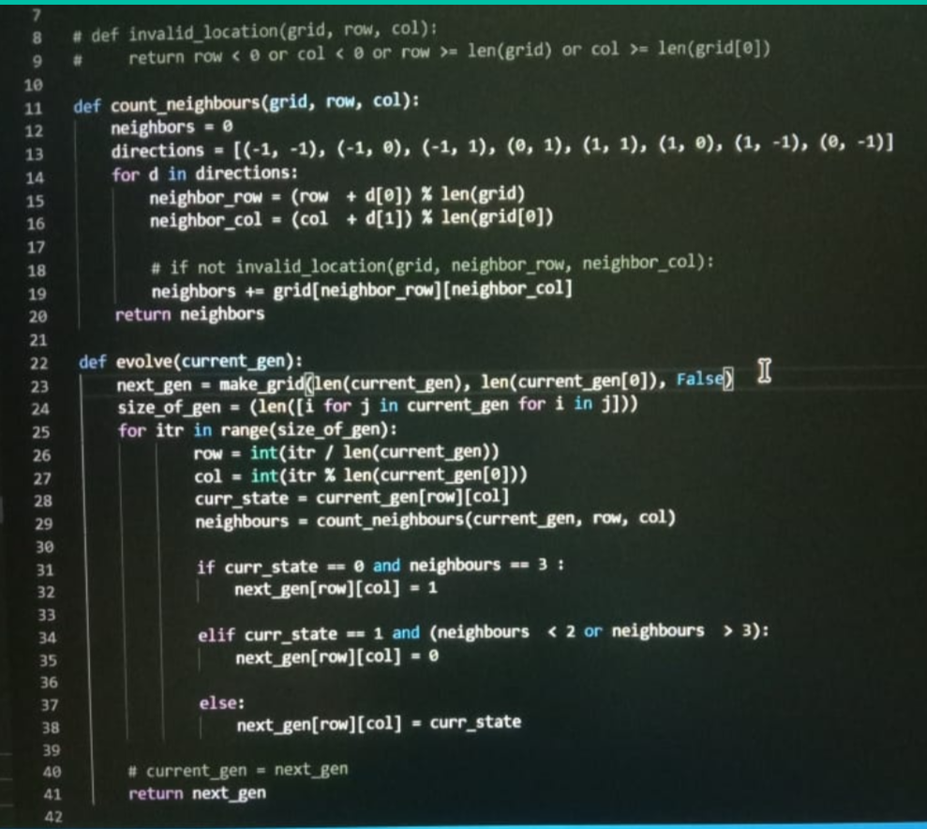

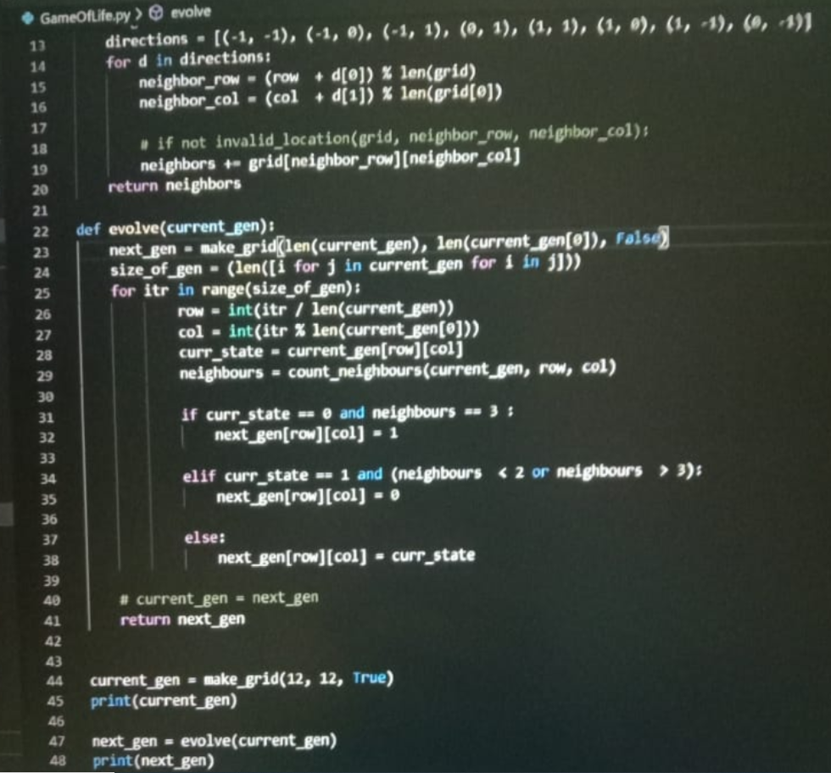

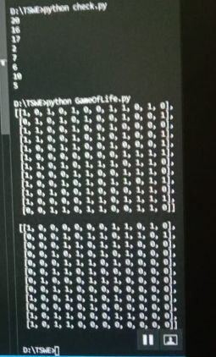 this is not infinite

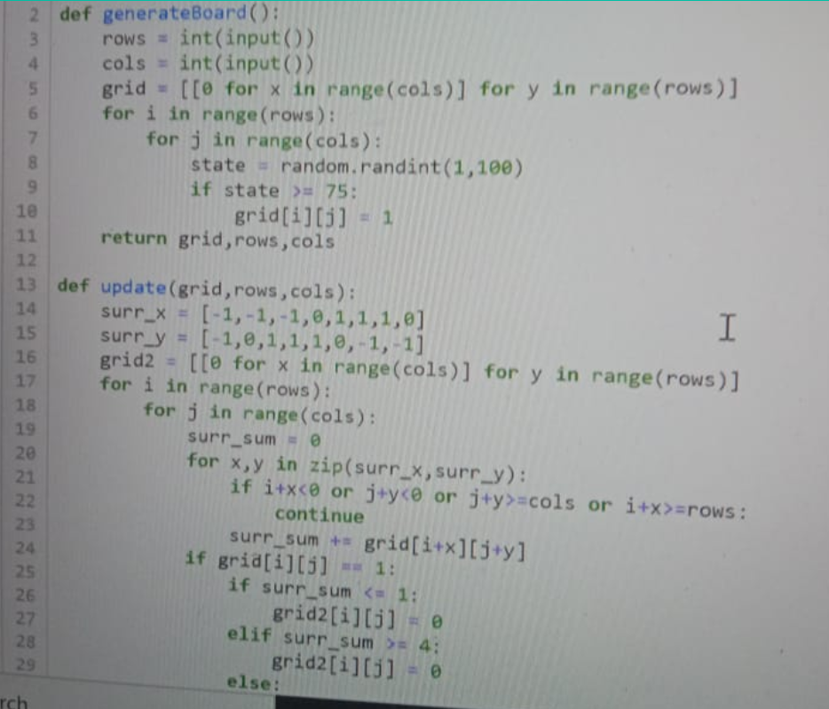

First line is import random

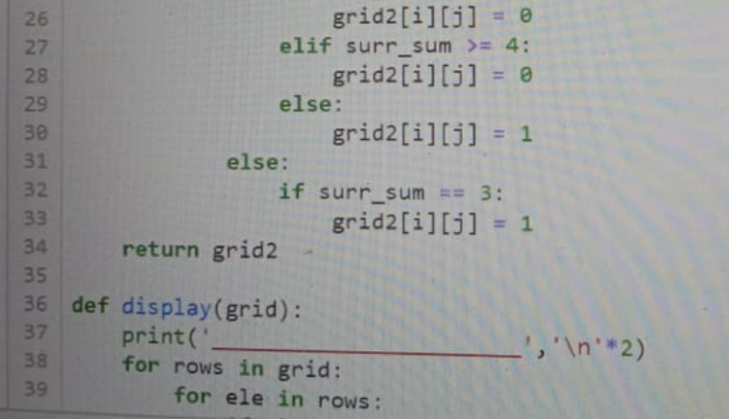

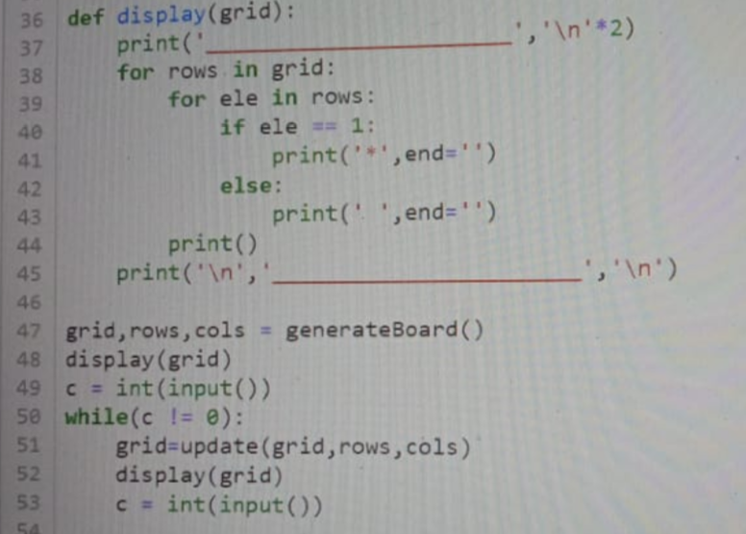

In principle, the Game of Life field is infinite, but computers have finite memory. This leads to problems when the active area encroaches on the border of the array. Programmers have used several strategies to address these problems. The simplest strategy is to assume that every cell outside the array is dead. This is easy to program but leads to inaccurate results when the active area crosses the boundary. A more sophisticated trick is to consider the left and right edges of the field to be stitched together, and the top and bottom edges also, yielding a toroidal array. The result is that active areas that move across a field edge reappear at the opposite edge.

Infinite matlab fir none will be on corners right?

Yes

Means each cell has 8 cell neighbours

how exactly is a grid infinite? suppose it will be in the constraints of our full screen size.. so at some point, edges WILL be encountered right? 😶

I think when the edges are reached, it adds a new row and column or something like that

The previous output is superimposed by the new output. Thats the inly way to handle infinite generation

[11:48 AM, 5/15/2020] Nimisha: now i think i don't really have one! I was thinking on the grid lines but they say we don't have to use it

<https://youtu.be/ouipbDkwHWA>

<https://bitstorm.org/gameoflife/>

<https://en.wikipedia.org/wiki/Conway%27s_Game_of_Life>

<https://youtu.be/ouipbDkwHWA>

1.Any live cell with fewer than two live neighbors dies, as if caused by under population.

2.Any live cell with two or three live neighbors lives on to the next generation.

3.Any live cell with more than three live neighbors dies, as if by overpopulation.

4.Any dead cell with exactly three live neighbors becomes a live cell, as if by reproduction.

PROGRAM 52 –

CROSSWORD

INPUT -

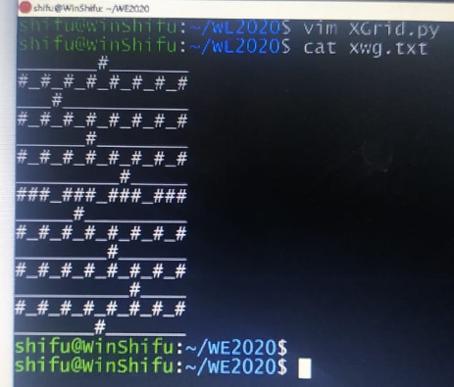

CODE –

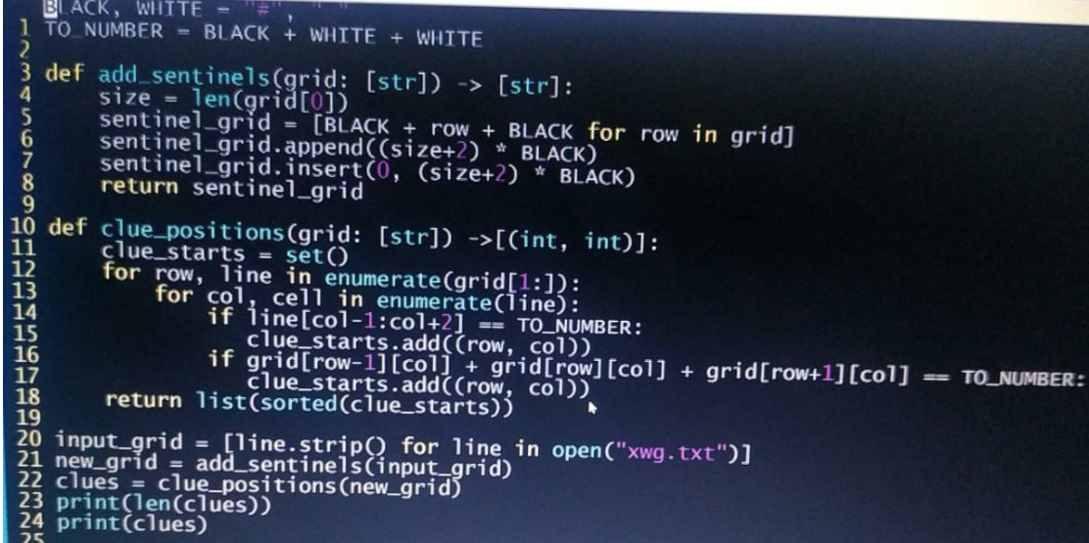

PROGRAM 53 –

NEWTON RALPSON METHOD

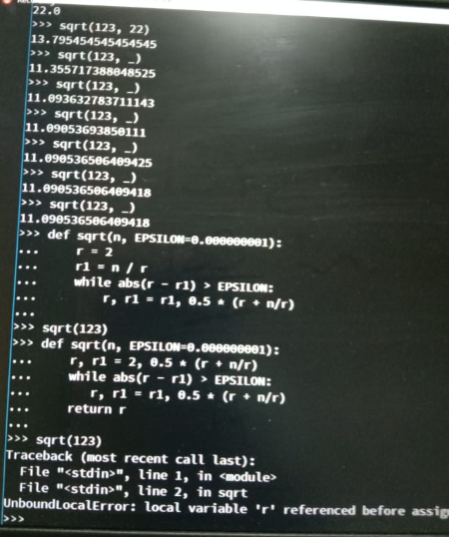

PROGRAM 54 –

PELICAN WEB PAGE DESIGING

https://docs.getpelican.com/en/stable/quickstart.html

https://www.fullstackpython.com/blog/generating-static-websites-pelican-jinja2-markdown.html

<https://pythonforundergradengineers.com/how-i-built-this-site-3.html>

<https://www.quora.com/What-is-the-tag-in-HTML-for-make-a-tab-space>

<https://stackoverflow.com/questions/35077507/how-to-right-align-and-justify-align-in-markdown>

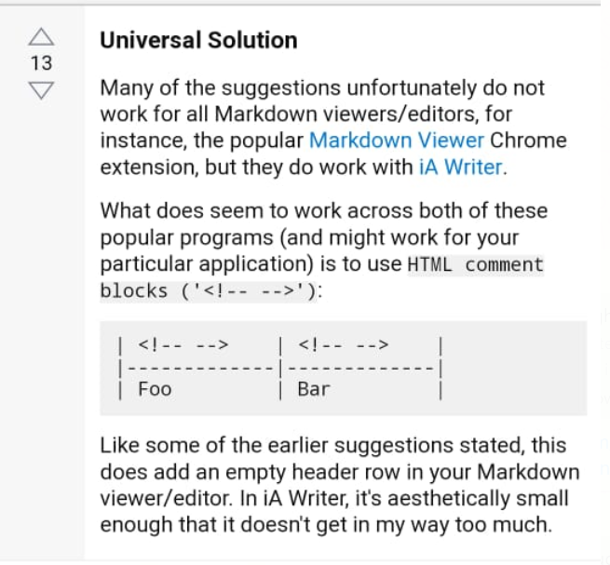

<https://stackoverflow.com/questions/25950595/pelican-plugins-not-found/25952812#25952812>

<https://youtu.be/pVTHM549gAk>

[6:51 AM, 5/14/2020] Nimisha: For adding comment section

[6:51 AM, 5/14/2020] Nimisha: Just don't paste the code in video to the html file. Just paste it at the bottom of your md file

[6:51 AM, 5/14/2020] Nimisha: In which you want the comments to show

<https://docs.getpelican.com/en/stable/>

[5:55 PM, 5/13/2020] Nimisha: Anyone added a link and it's working?

[5:55 PM, 5/13/2020] Nimisha: yeah I used html in .md file and it worked fine

[6:09 PM, 5/13/2020] Nimisha: git --clone * GitHub link *

<https://pythonforundergradengineers.com/how-i-built-this-site-3.html>

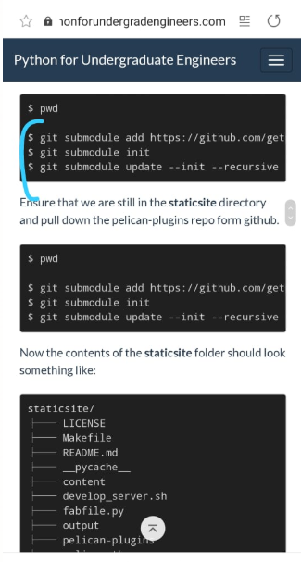

<https://www.fullstackpython.com/blog/generating-static-websites-pelican-jinja2-markdown.html>

<https://docs.getpelican.com/en/stable/quickstart.html>

<http://crontab.guru/>

PROGRAM 55 –

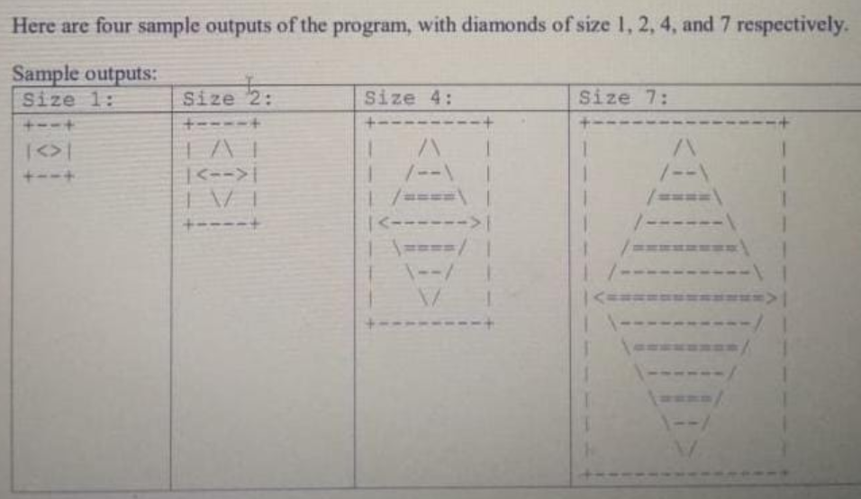

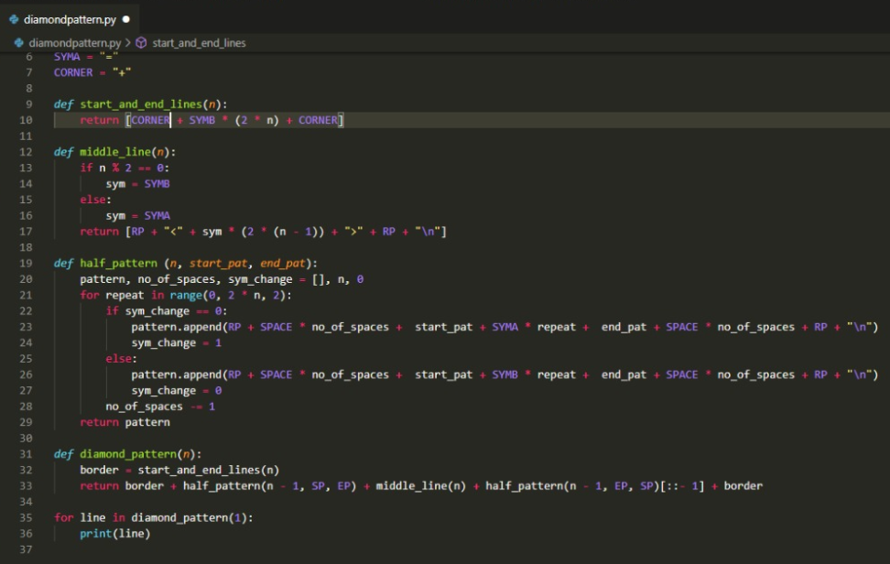

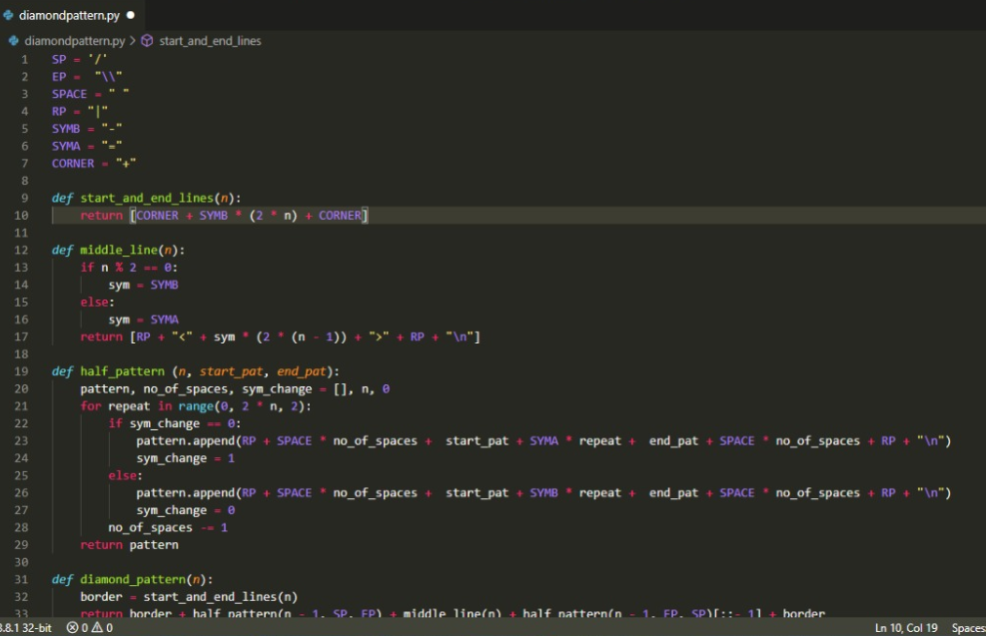

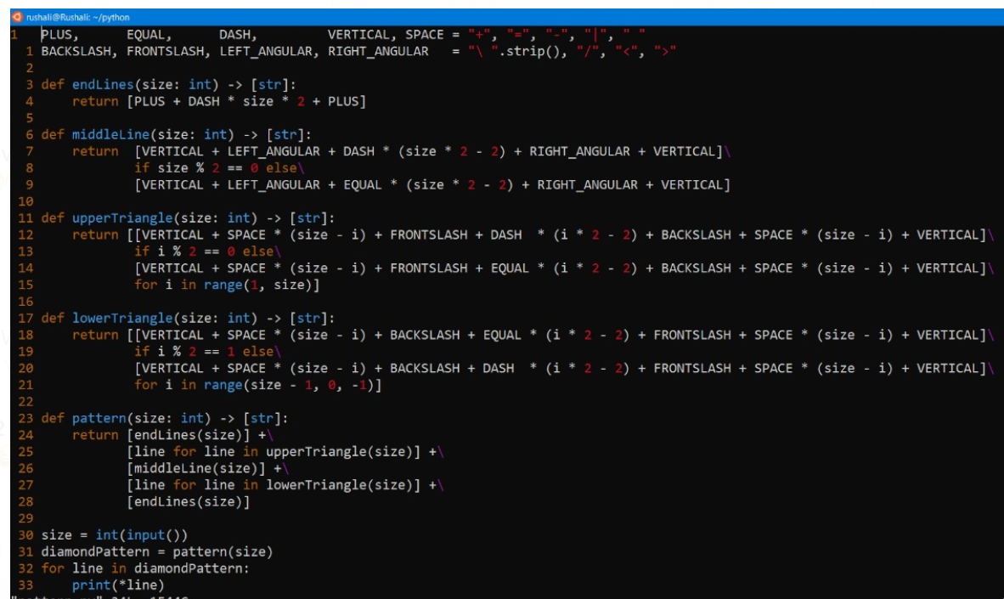

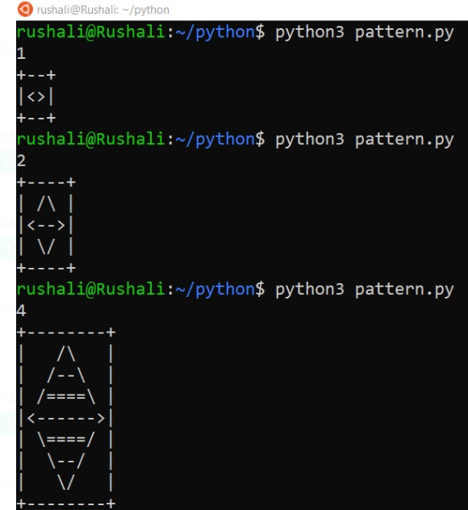

PROGRAM 56-

RANKING

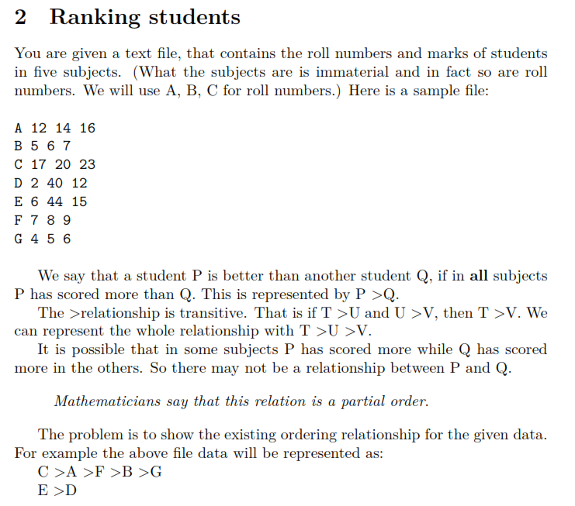

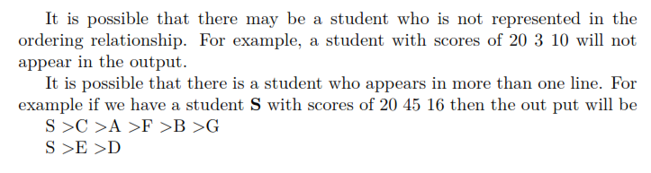

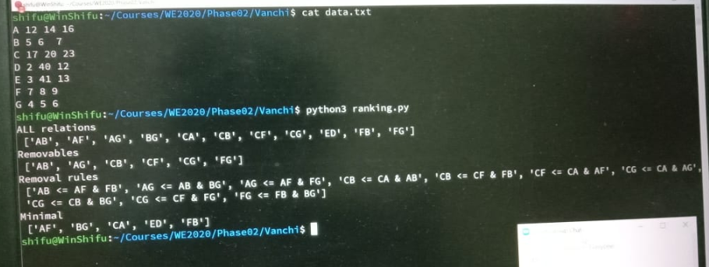

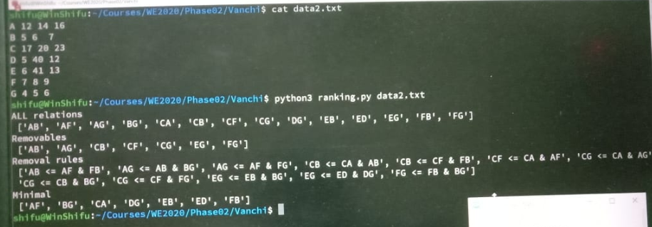

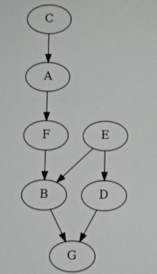 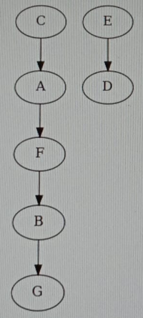

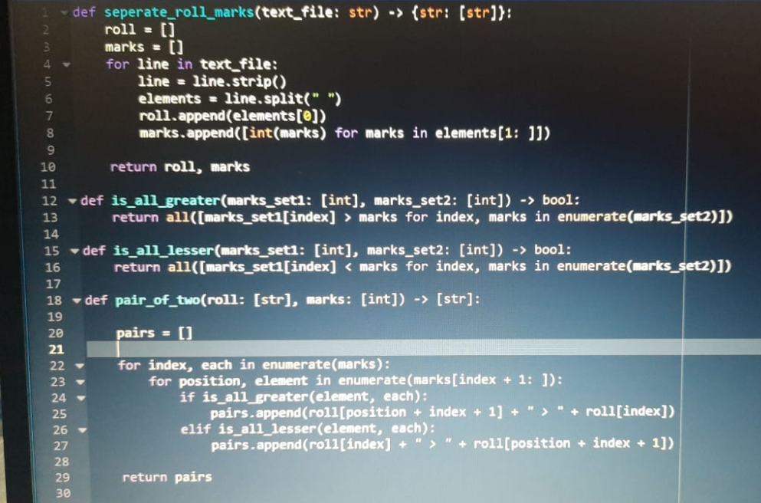

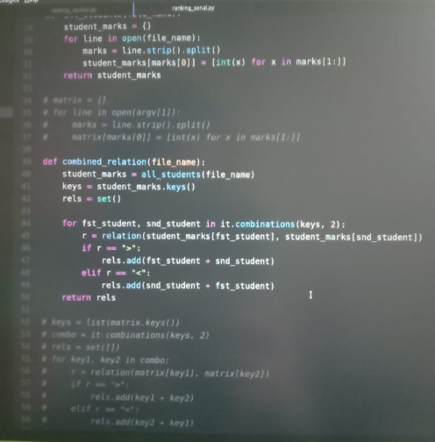

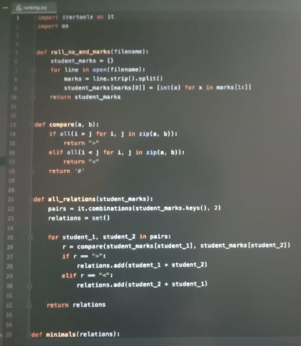

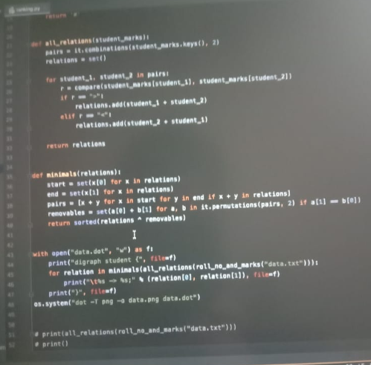

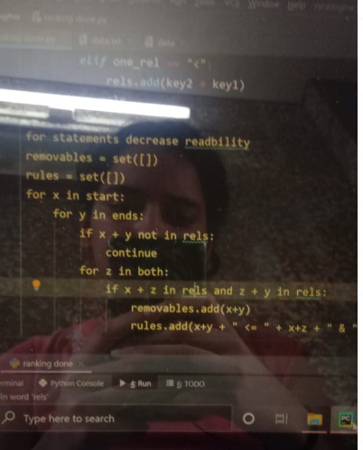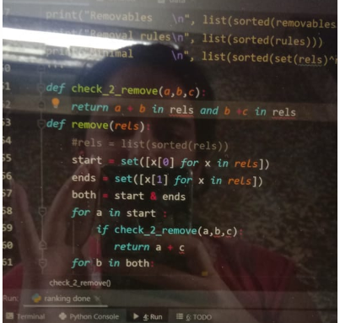

[11:59 AM, 5/11/2020] Nimisha: No, no need, dot files can be used with the dot command line to create png

[11:59 AM, 5/11/2020] Nimisha: https://graphviz.gitlab.io/_pages/pdf/dotguide.pdf

[11:59 AM, 5/11/2020] Nimisha: Clean up the code, refactor it and make it work.

asokan has written this na... so this only implies formatting the code better na? or does he want us to work on the logic too?

[11:59 AM, 5/11/2020] Nimisha: uhh basically he's drawing out relations between pairs of 2 students then he's finding the ones that are common to two like the starting of one relation and ending of another realtion so the that he can remove the direct link like AF FB AB so AB can be removed llike that so he gave us the basic idea of the question

[11:59 AM, 5/11/2020] Nimisha: in finding Minimals we are using XOR operator. Can someone explain what's really happening there and what exactly are Minimals?

[11:59 AM, 5/11/2020] Nimisha: for key1, key2 in combo:

r = relation(matrix[key1], matrix[key2])

if r == ">":

rels.add(key1 + key2)

elif r == "<":

rels.add(key2 + key1)

[11:59 AM, 5/11/2020] Nimisha: for x in start:

for y in ends:

if x + y not in rels:

continue

for z in both:

if x + z in rels and z + y in rels:

removables.add(x+y)

rules.add(x+y + " <= " + x+z + " & " + z+y )

[11:59 AM, 5/11/2020] Nimisha: its just removing the pairs which have a element in between

[11:59 AM, 5/11/2020] Nimisha: like A > F > B

[11:59 AM, 5/11/2020] Nimisha: it will remove the pair AB

[11:59 AM, 5/11/2020] Nimisha: because B does not come exactly after A

[11:59 AM, 5/11/2020] Nimisha: just to avoid chances of repetition i guess he must used a set otherwise i don't know

[11:59 AM, 5/11/2020] Nimisha: Here are the numbers for morning batch

[11:59 AM, 5/11/2020] Nimisha: 3n +1 = pelican(docs.getpelican.com/en/stable/) create bunch of html pages+ chess problem

PROGRAM 57 –

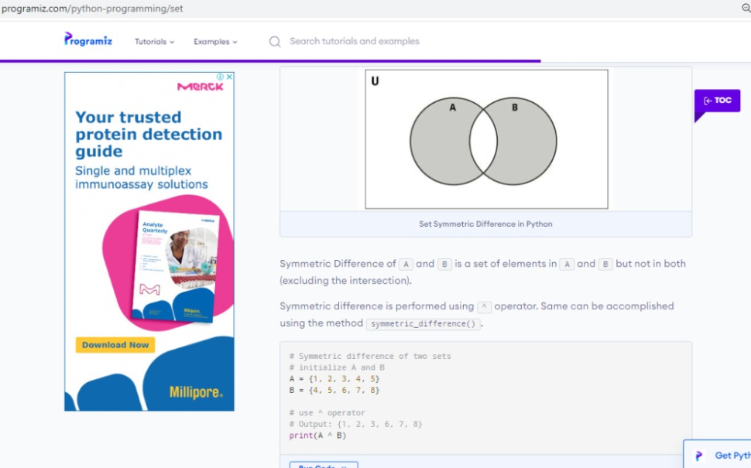

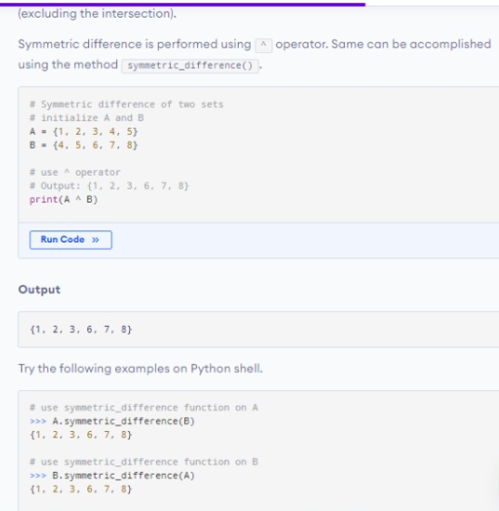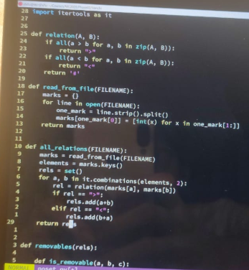

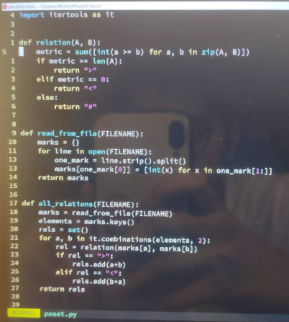 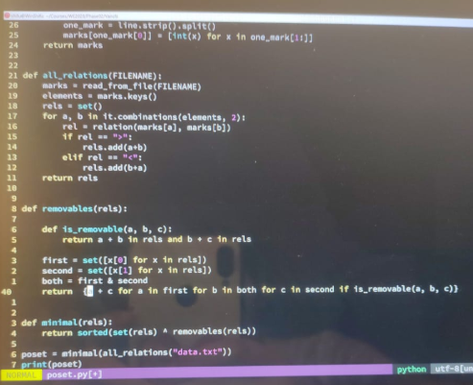

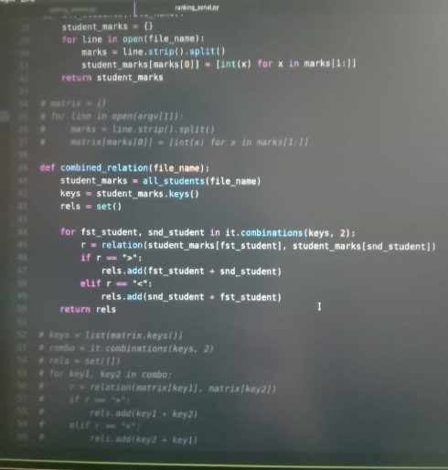

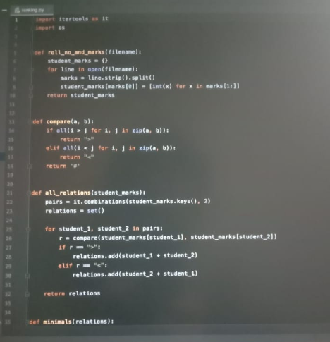

PROGRAM 58 –

Graphviz

<https://graphviz.readthedocs.io/en/stable/examples.html>

<https://youtu.be/z-AGmGmR6Z8>

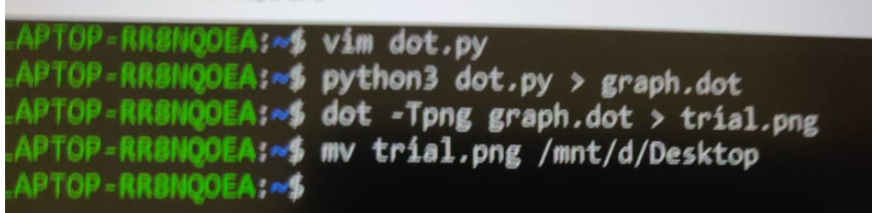

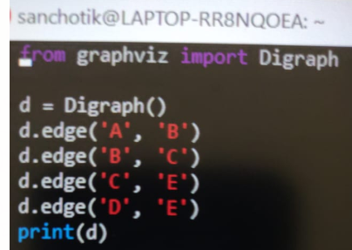  

pip3 install graphviz

[12:45 PM, 5/10/2020] Nimisha: install pip

[12:45 PM, 5/10/2020] Nimisha: sudo apt install python3-pip

[12:45 PM, 5/10/2020] Nimisha: dot - Tpng file.dot > filename.png

[12:45 PM, 5/10/2020] Nimisha: Another way would be

dot - Tpng file.dot - O filename.png

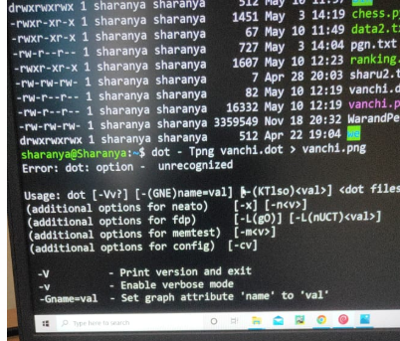 Space after T

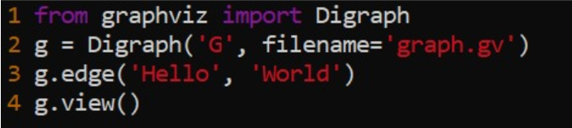

<https://dreampuf.github.io/GraphvizOnline/#digraph%20vanchi%20%7B%0D%0A%20%20%20%20%20%20A%20-%3E%20F%3B%0D%0A%20%20%20%20%20%20B%20-%3E%20G%3B%0D%0A%20%20%20%20%20%20C%20-%3E%20A%3B%0D%0A%20%20%20%20%20%20E%20-%3E%20D%3B%0D%0A%20%20%20%20%20%20F%20-%3E%20B%3B%0D%0A%7D%0D%0A%20%20%20%20%20%20%20%20%20%20%20%20%20%20%20%20%20%20%20%20%20%20%20%20%20%20%20%20%20%20%20%20%20%20%20%20%20%20%20%20%20%20%20%20%20%20%20%20%20%20%20%20%20%20~%20%20%20%20%20%20%20%20%20%20%20%20%20%20%20%20%20>

[4:39 PM, 5/10/2020] Nimisha: ust type your dot code here

[4:39 PM, 5/10/2020] Nimisha: https://renenyffenegger.ch/notes/tools/Graphviz/examples/index

[4:39 PM, 5/10/2020] Nimisha: i copied from windows to current directory

[4:39 PM, 5/10/2020] Nimisha: If we make a new dot file ... filename.dot

[4:39 PM, 5/10/2020] Nimisha: Then how do we make it filename.png?

[4:39 PM, 5/10/2020] Nimisha: So that we can get the output the way we got for vanchi.png

[4:39 PM, 5/10/2020] Nimisha: shyad aise somebody said sent this a while ago

[4:39 PM, 5/10/2020] Nimisha: I got it

[4:39 PM, 5/10/2020] Nimisha: Go to root

[4:39 PM, 5/10/2020] Nimisha: sudo su -

[4:39 PM, 5/10/2020] Nimisha: cp /mnt/c/....pathname ~/



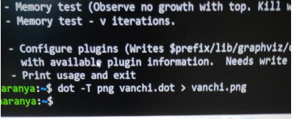

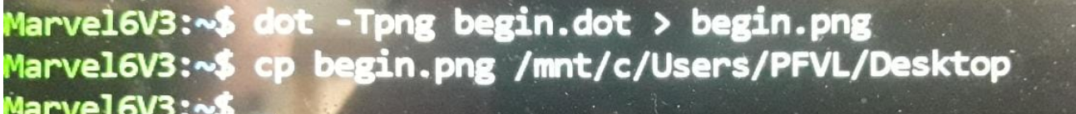

PROBLEM 59 –

LATEX

